Using minikube for deplyoing prometheus

1. Create namespace and role with read access

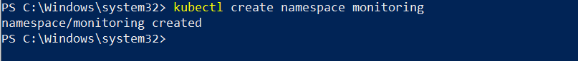

2. Create the role

## 3. Create a Config Map To Externalize Prometheus Configurations

## 

## 

Set up Aletrs

Cloned GitHub repo and run the following commands for creating a pod for alerts.

Set up Graphana

Cloned the GitHub repo for grafana and created all the yml files, as we can see its running and we are connecting to it though the following command.

